Microsoft 365 系統管理中心說明 | Microsoft Learn
https://learn.microsoft.com/zh-tw/microsoft-365/admin/?view=o365-worldwide

安全性事件管理 - Microsoft 365 Business Premium | Microsoft Learn
https://learn.microsoft.com/zh-tw/microsoft-365/business-premium/m365bp-security-incident-management?view=o365-worldwide

How to check login activity on Microsoft 365
https://www.manageengine.com/microsoft-365-management-reporting/kb/how-to-check-login-activity-on-microsoft-365.html

Dear Allen哥
如上週跟您詢問的，我的工項如下，
說白話就是看看 客戶端AAD的受控網域 有沒有
- 網域狀態
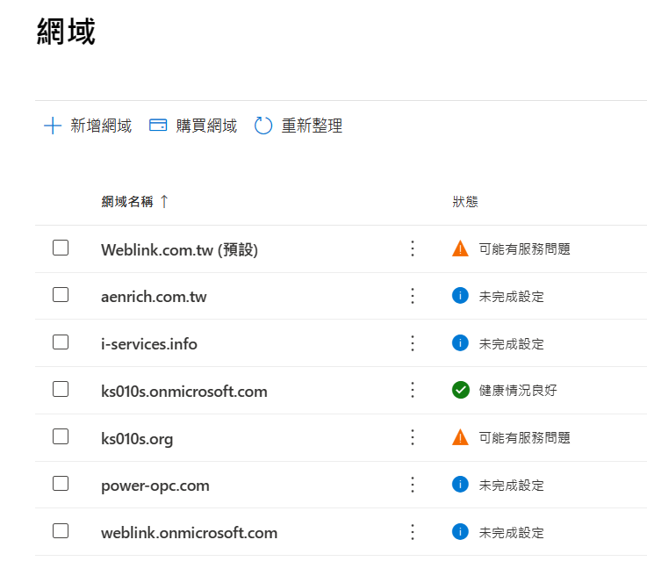

- Exchange 信箱使用狀況 (信箱容量、閒置信箱確認)
https://portal.office.com/adminportal#/reportsUsage/EmailActivity
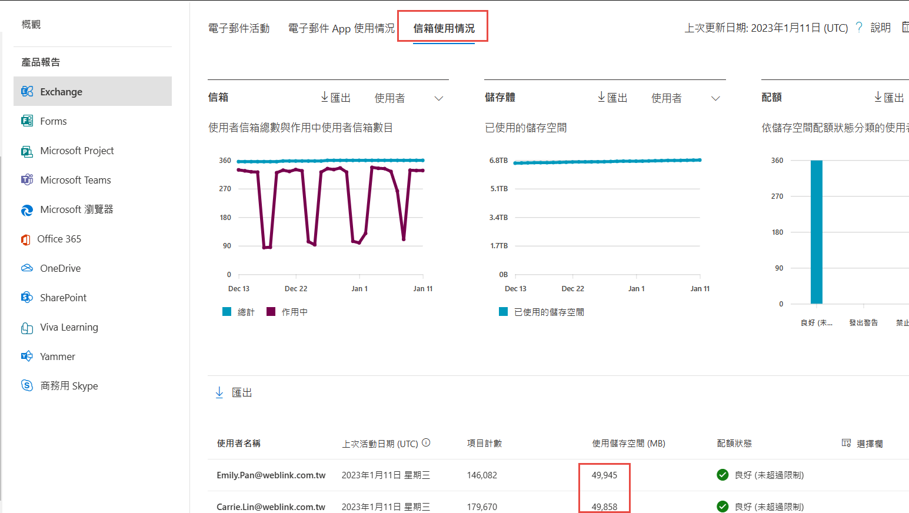

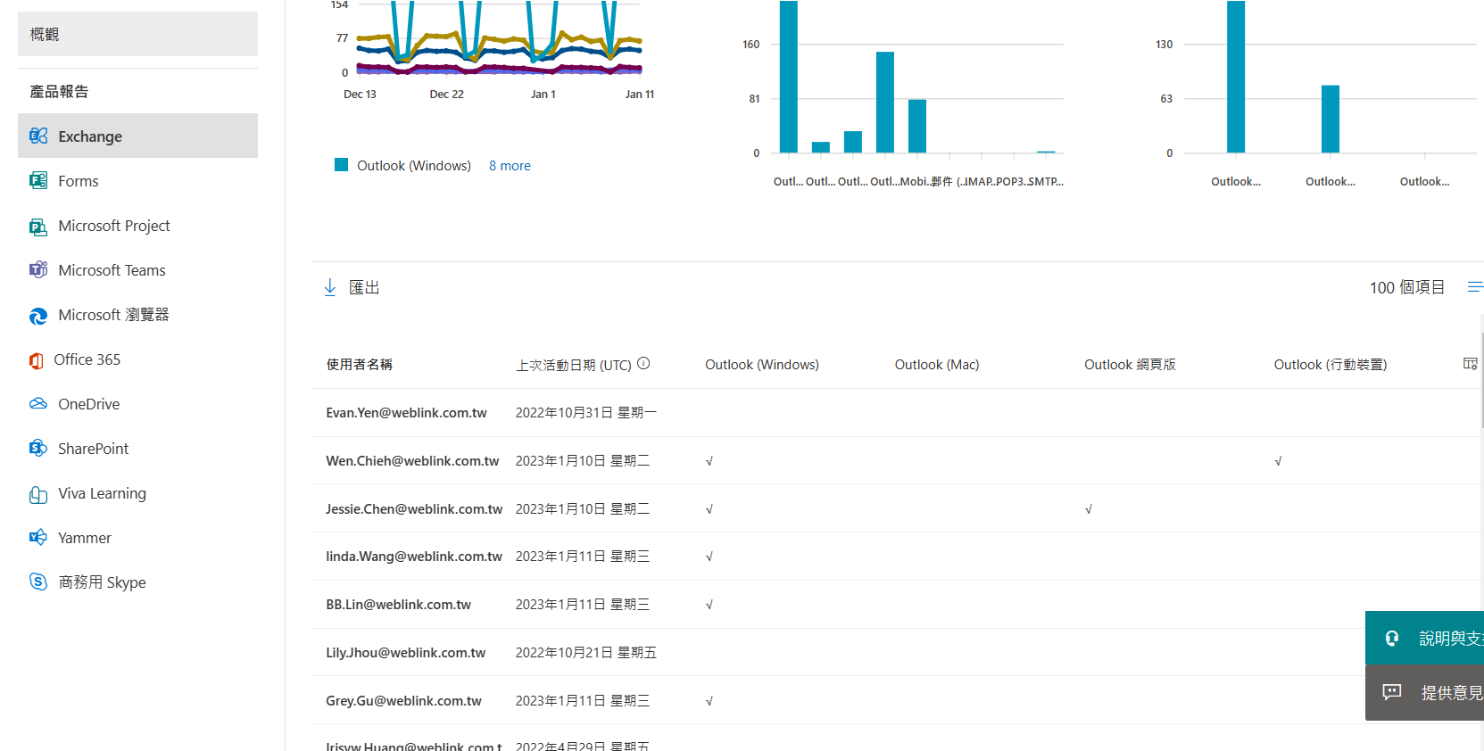

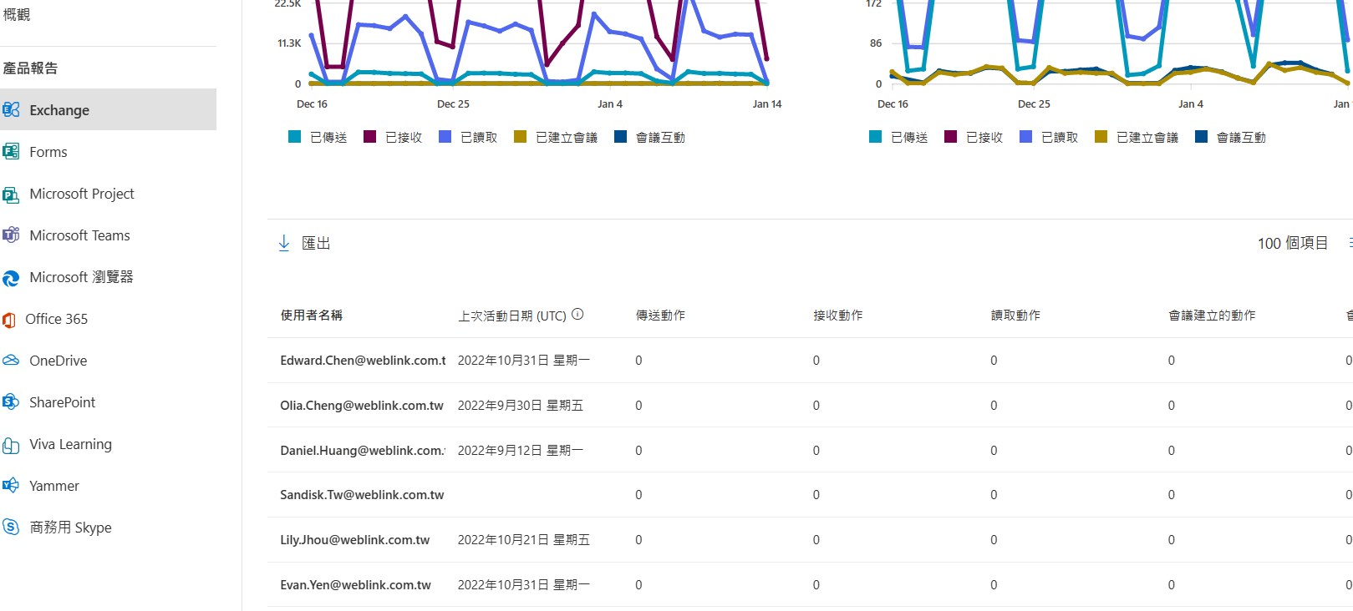

- 未使用的 Exchange online 授權
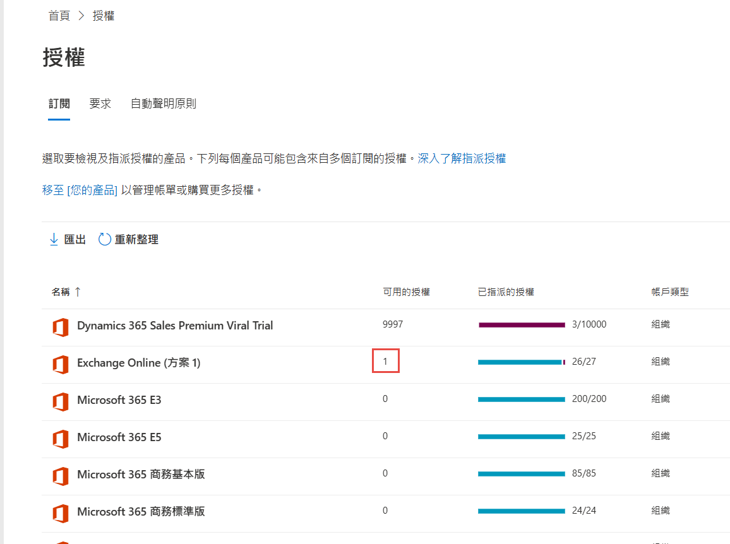

- 檢查 Azure Active Directory Domain Services 受控網域的健康情況
https://admin.microsoft.com/AdminPortal/Home?#/servicehealth
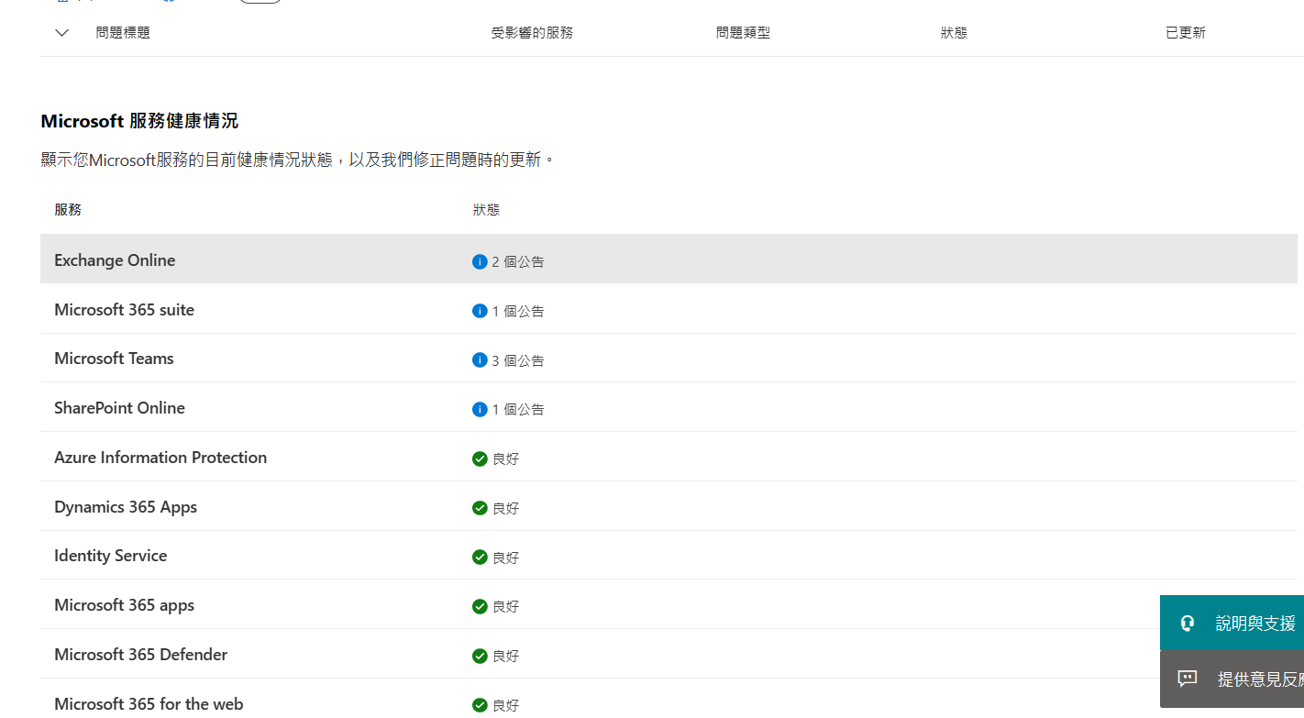

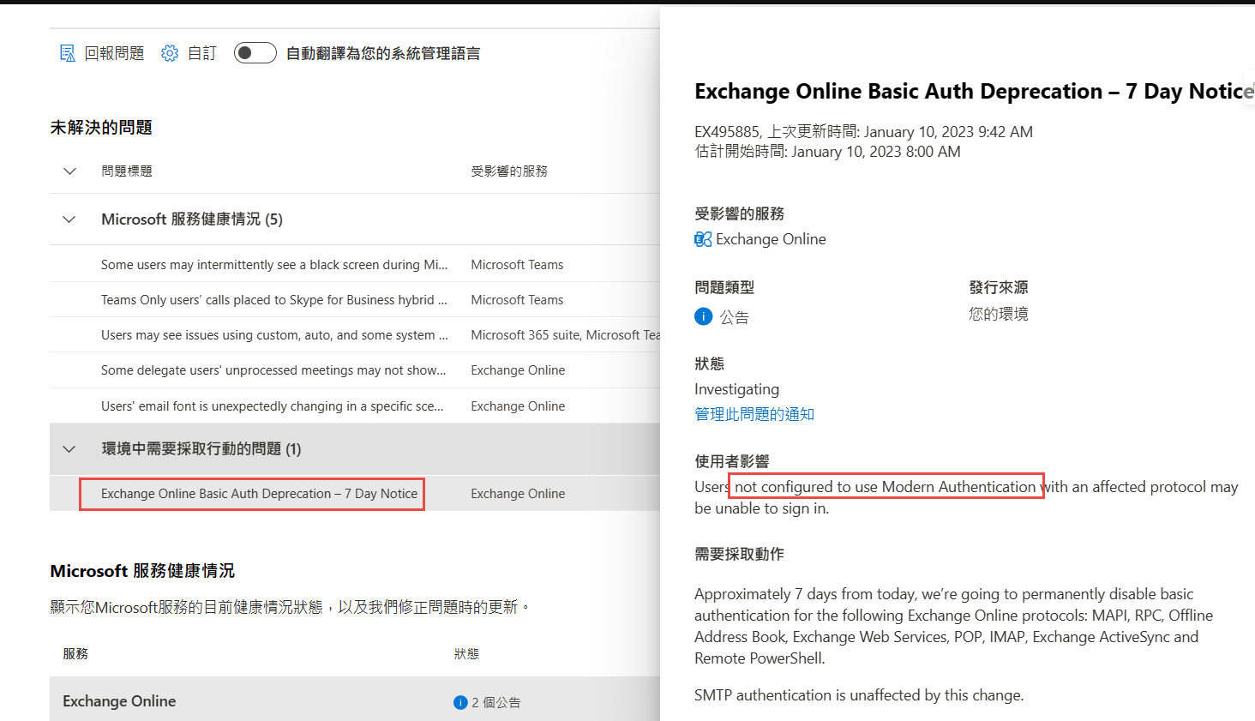

- Microsoft 365 入口網站和系統管理中心存取
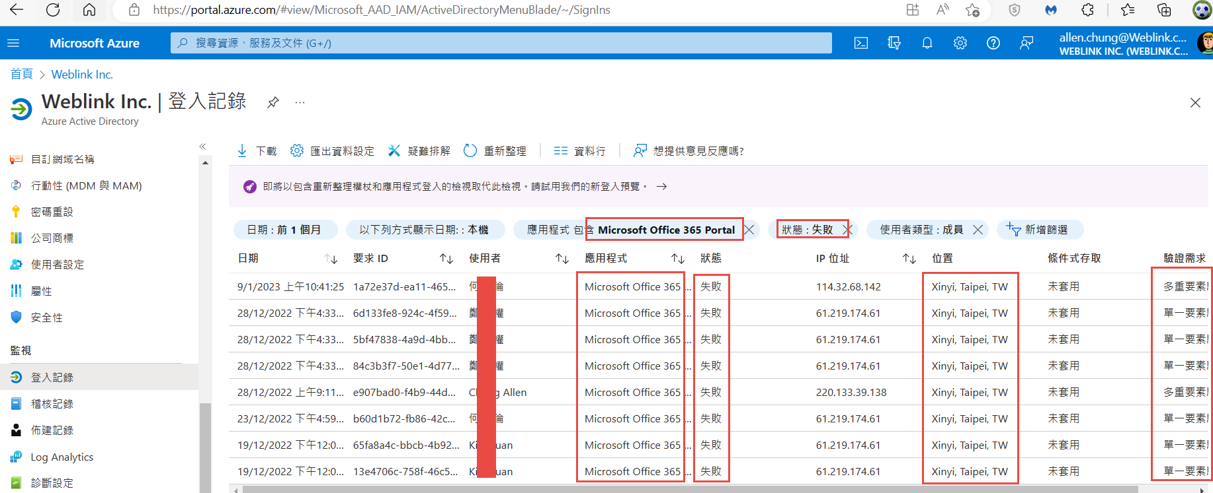

Exchange 系統管理中心存取
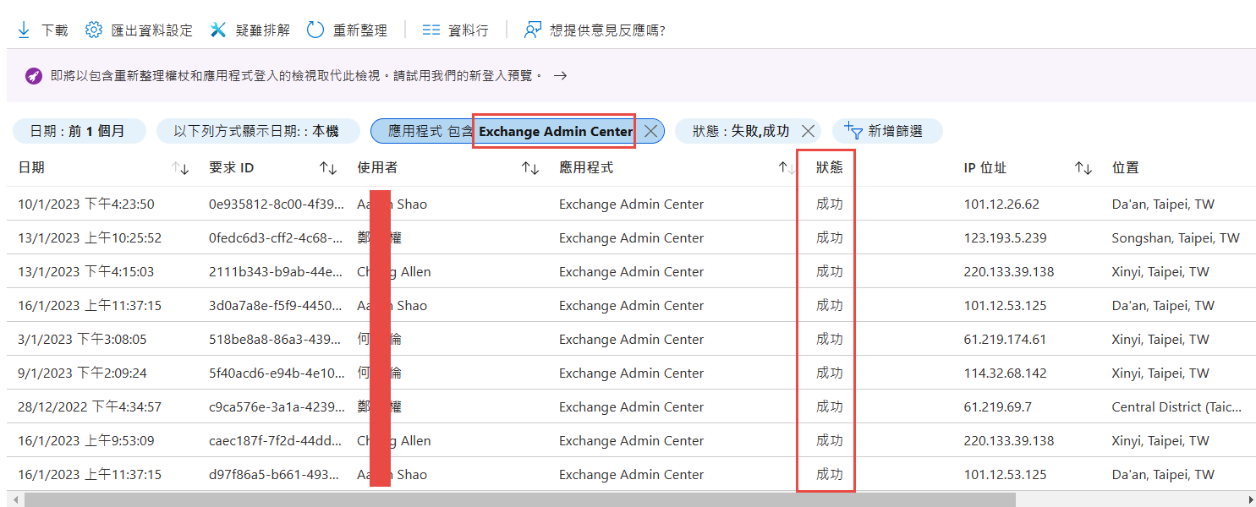

行動裝置
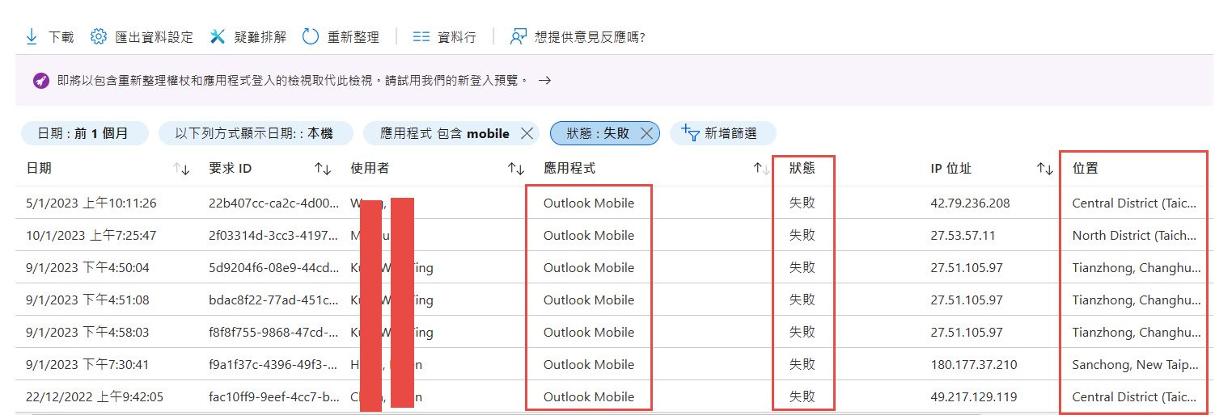

- 遠端Exchange Online PowerShell存取
關於 Exchange Online PowerShell V2 模組和 V3 模組 | Microsoft Learn
https://learn.microsoft.com/zh-tw/powershell/exchange/exchange-online-powershell-v2?view=exchange-ps

安裝和維護 Exchange Online PowerShell 模組
https://www.powershellgallery.com/packages/ExchangeOnlineManagement/3.1.0
Install-Module -Name ExchangeOnlineManagement
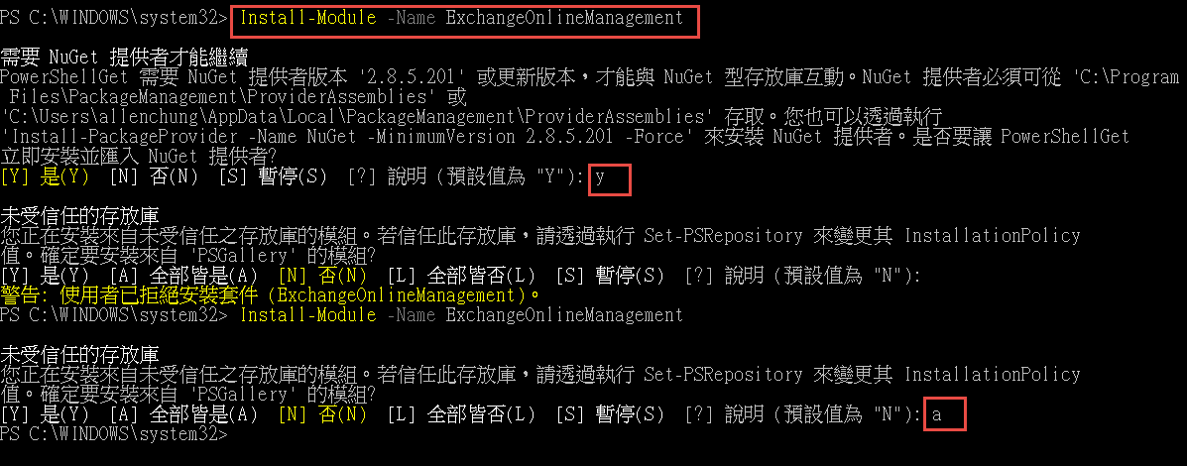
連線至 Exchange Online PowerShell | Microsoft Learn
https://learn.microsoft.com/zh-tw/powershell/exchange/connect-to-exchange-online-powershell?view=exchange-ps

Import-Module ExchangeOnlineManagement
因為這個系統上已停止指令碼執行
https:/go.microsoft.com/fwlink/?LinkID=135170
Get-ExecutionPolicy
Get-ExecutionPolicy -List
Get-ExecutionPolicy -Scope CurrentUser
Set-ExecutionPolicy -ExecutionPolicy RemoteSigned

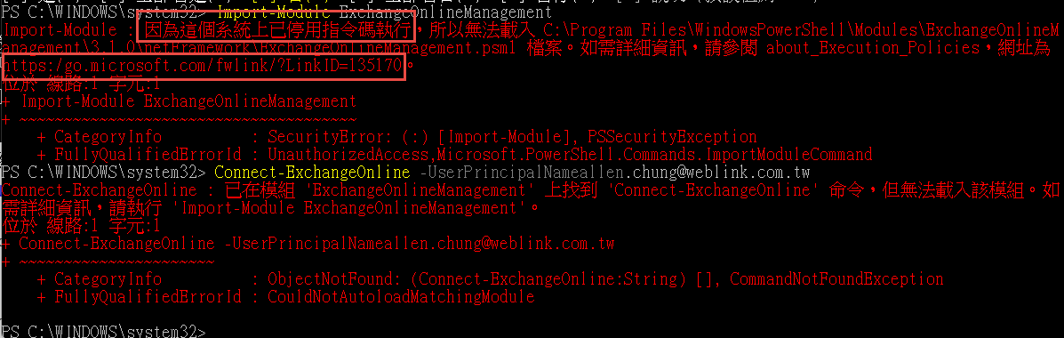
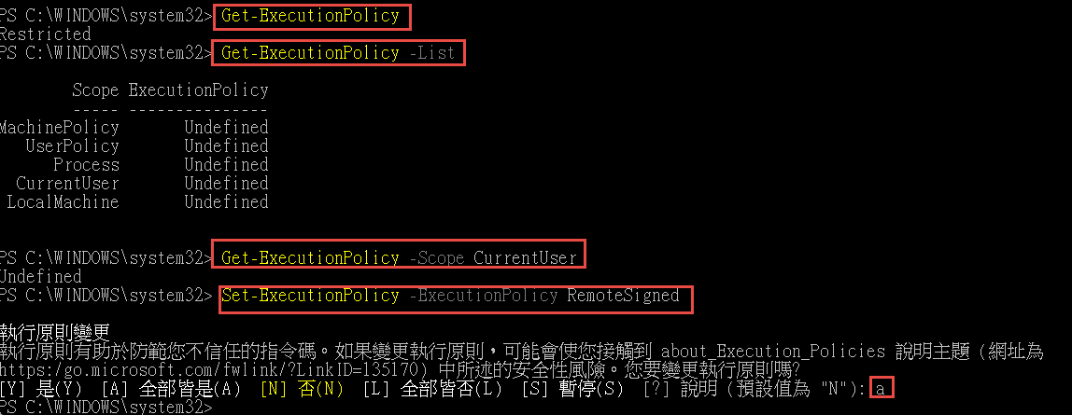
Connect-ExchangeOnline -UserPrincipalName <UPN> [-UseRPSSession] [-ExchangeEnvironmentName <Value>] [-ShowBanner:$false] [-DelegatedOrganization <String>] [-PSSessionOption $ProxyOptions]
Connect-ExchangeOnline -UserPrincipalName navin@contoso.onmicrosoft.com
Connect-ExchangeOnline -UserPrincipalName allen.chung@weblink.com.tw
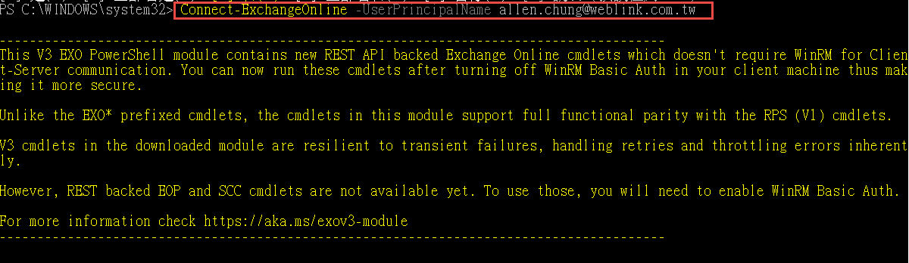

若要顯示所有使用者Exchange Online PowerShell 存取狀態，請執行下列命令
Get-User -ResultSize unlimited | Format-Table -Auto Name,DisplayName,RemotePowerShellEnabled
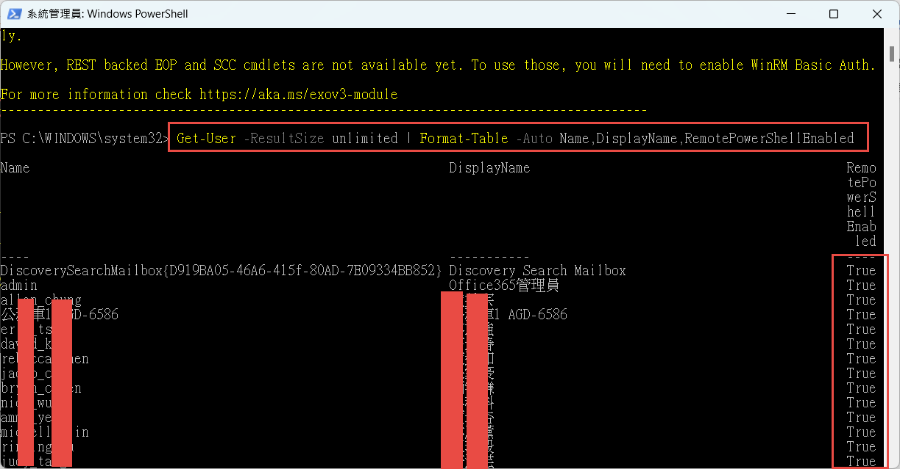

- ActiveSync 原則使用量報告
在 Office 365 中管理裝置的 Exchange ActiveSync 原則 - Microsoft Support
https://support.microsoft.com/zh-hk/topic/%E5%9C%A8-office-365-%E4%B8%AD%E7%AE%A1%E7%90%86%E8%A3%9D%E7%BD%AE%E7%9A%84-exchange-activesync-%E5%8E%9F%E5%89%87-b6b17f00-6997-450d-9992-22f84a18c9e5

Exchange Online 中的 Exchange ActiveSync | Microsoft Learn
https://learn.microsoft.com/zh-tw/exchange/clients-and-mobile-in-exchange-online/exchange-activesync/exchange-activesync#managing-exchange-activesync

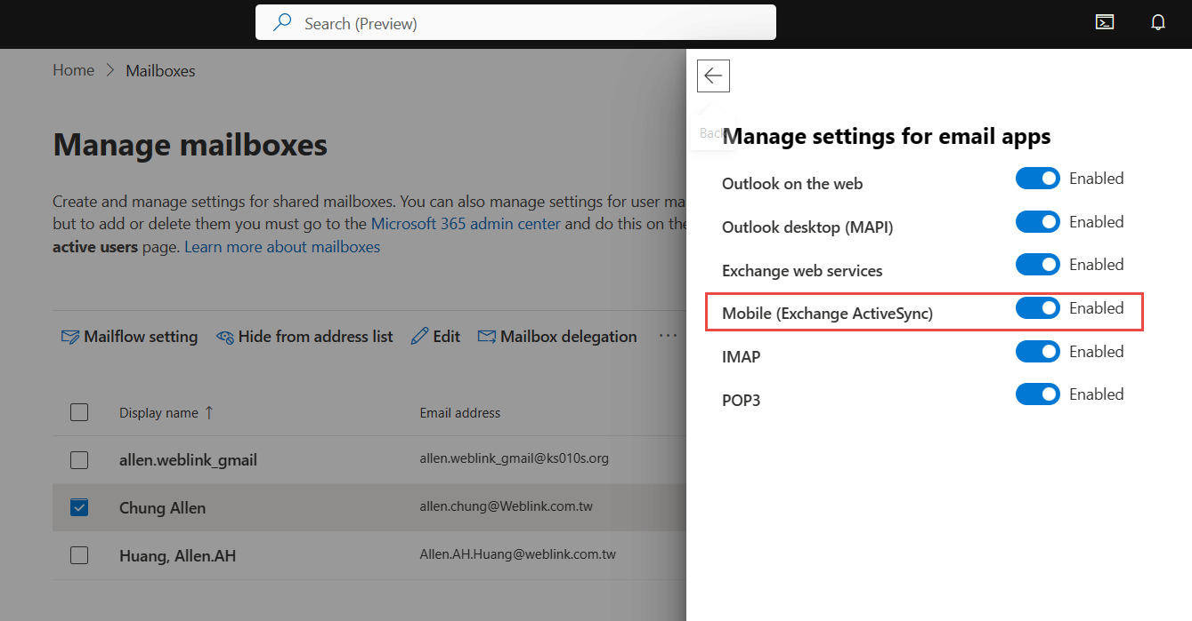

3.Microsoft 365 系統管理中心報表
Excel 報告活頁簿、Web 服務報告,

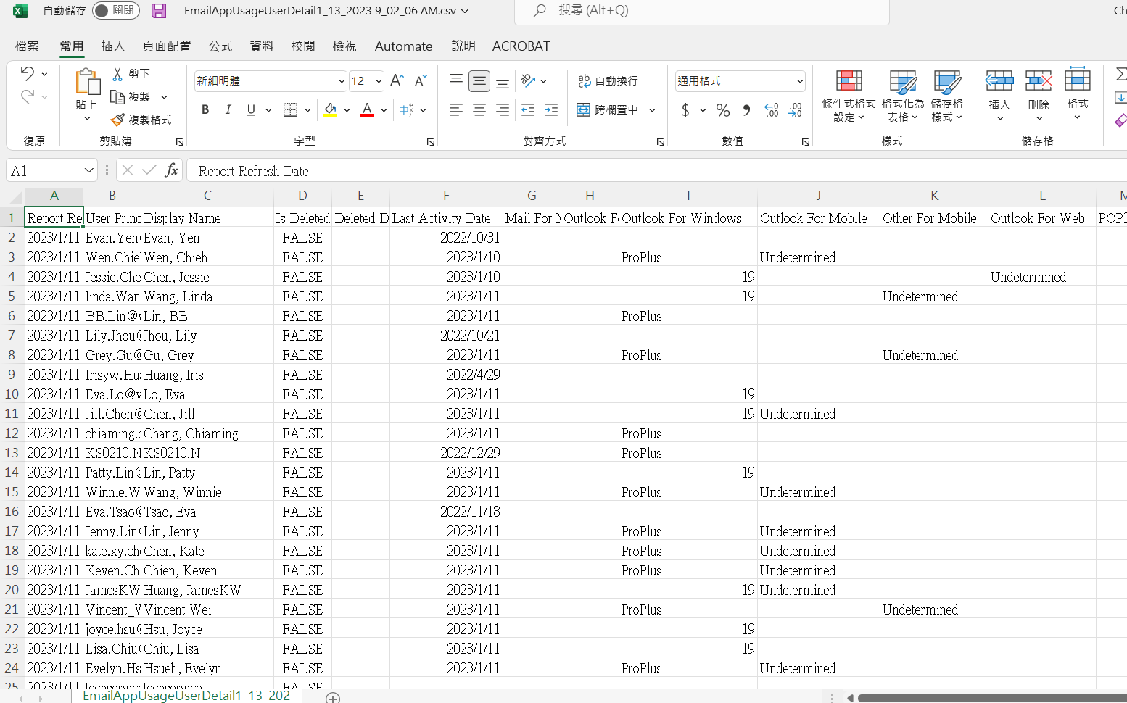

- 訊息追蹤和稽核報告
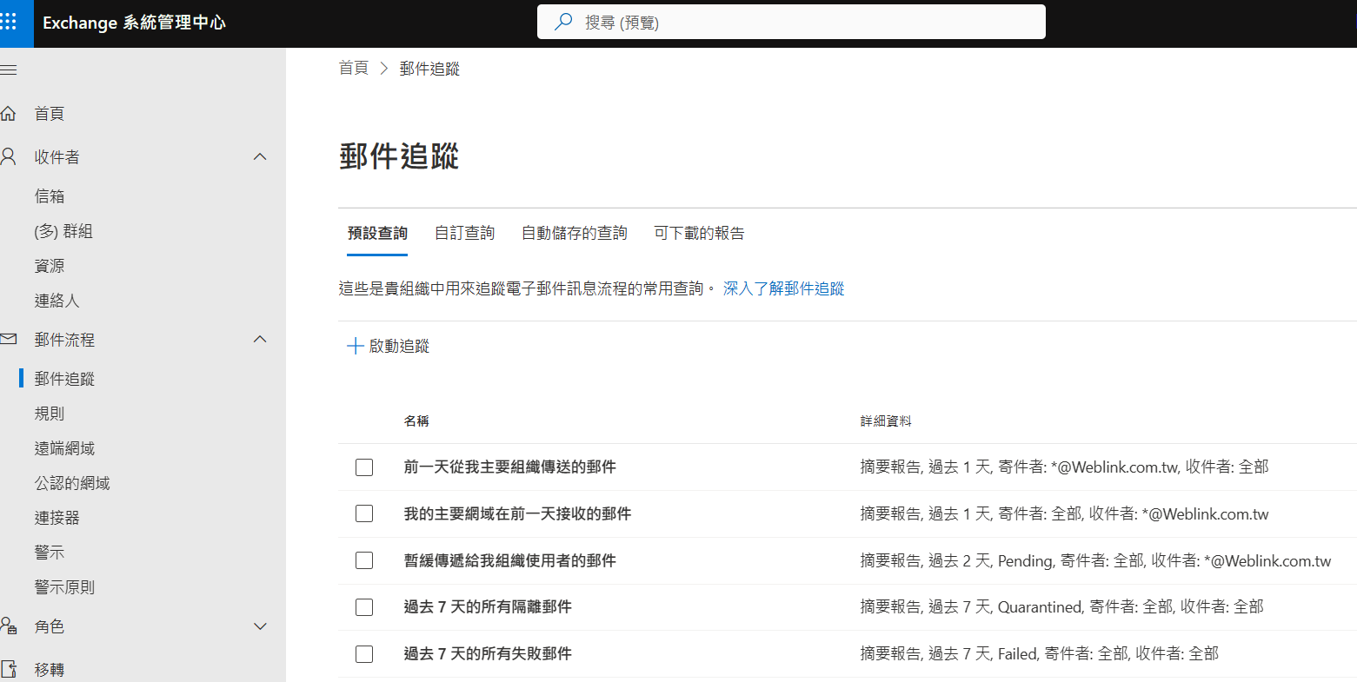

- 管理員 MFA
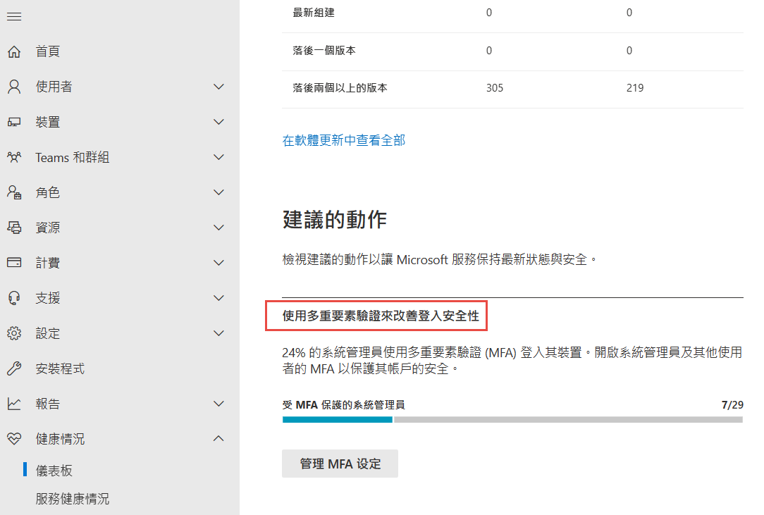

https://outlook.office365.com/ecp/?p=ActiveSyncAccess&form=eac

封鎖、允許、擦除或刪除裝置
Exchange 系統管理中心: 收件者 select user信箱] 索引標籤 > select user > 按一下 [行動裝置] 底下的 [查看詳細資料
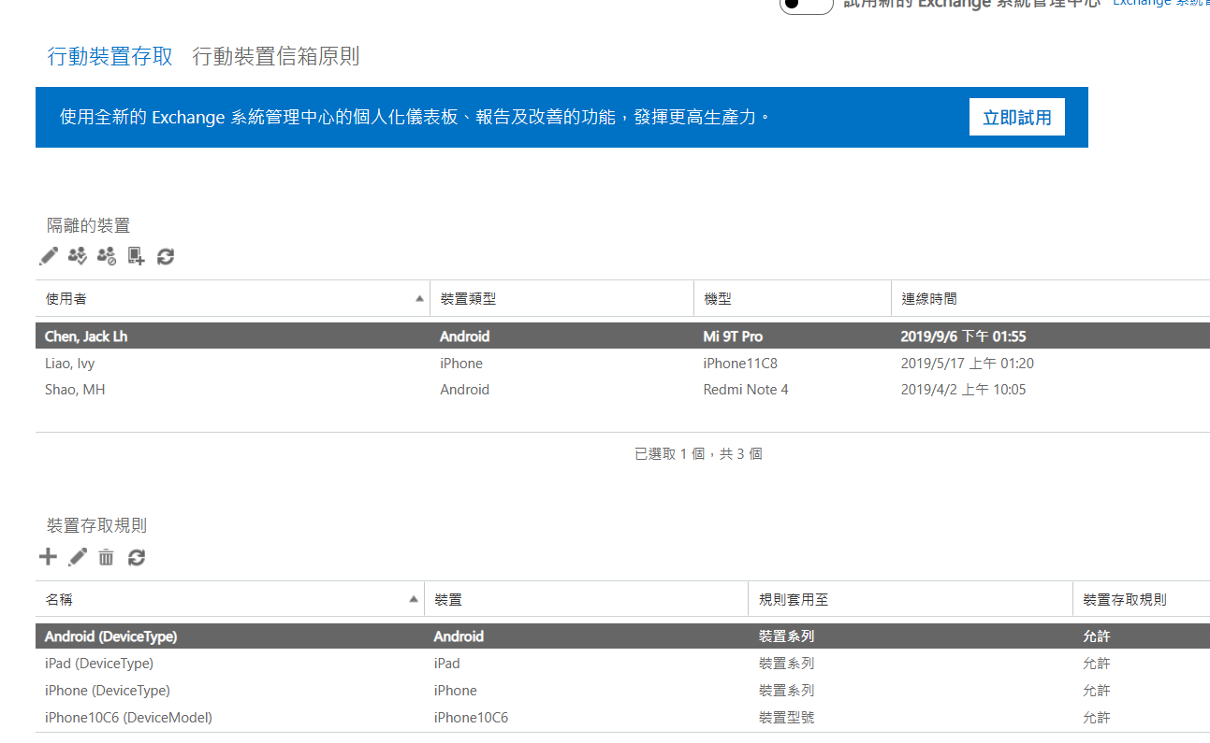

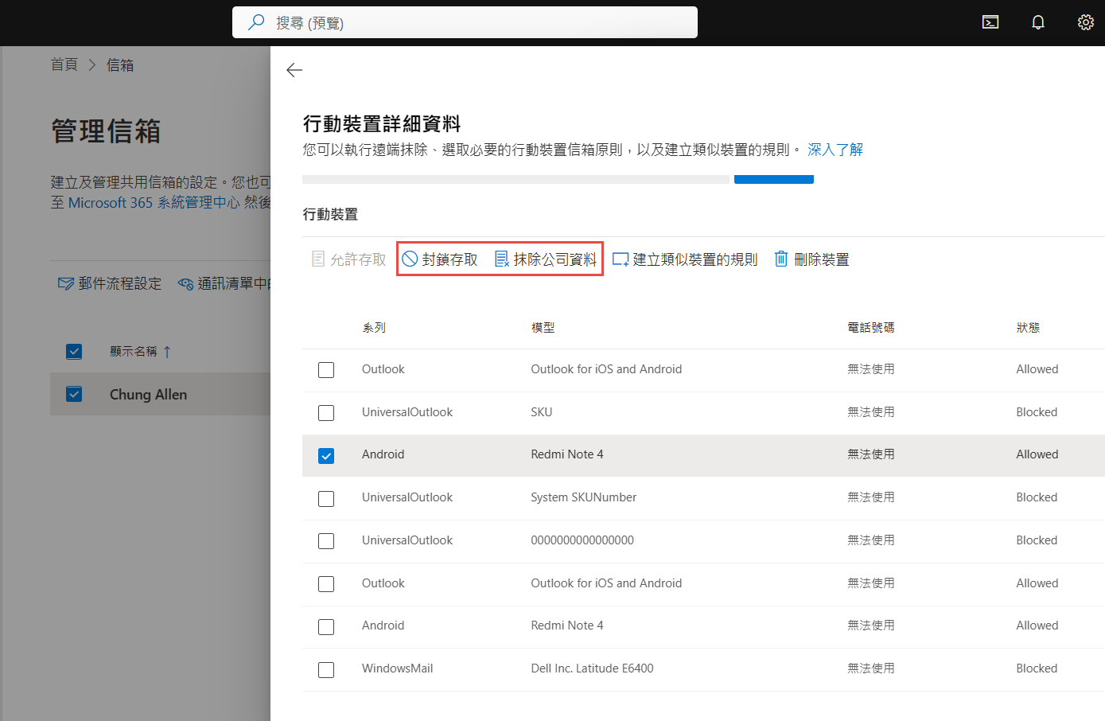

- AAD connect sync error
Azure Active Directory Connect Health - Microsoft Azure
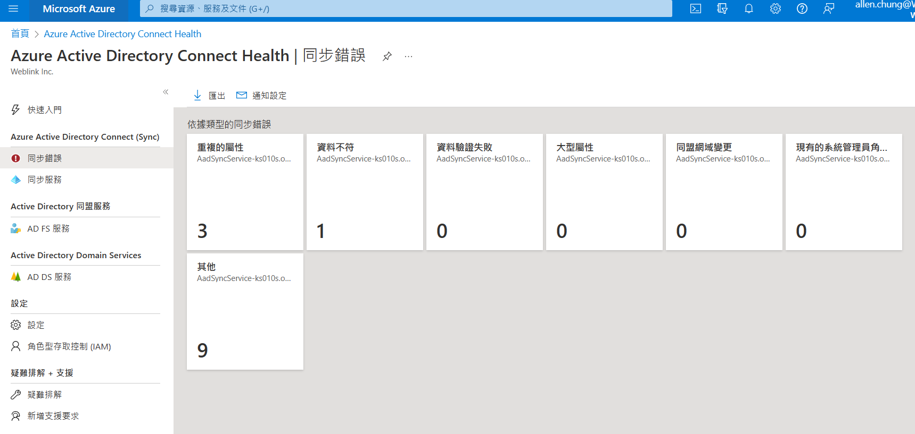

https://security.microsoft.com/auditlogsearch?viewid=Async%20Search&tid=4ceef0d2-1582-44b4-84dc-2f8e05f5fba1

